CIS 320-01

Dr. Robert Barker

**Inception Phase Specification:**

**The GallOp Project**

**Fine Equine:**

Abdulaziz Arrak, Madeline Cowgill, Diana Durig,

Vin Lam, Shivani Patel, and Henry Wang

**System Request – GallOp System**

|  |
| --- |
| **Project Sponsor:** Dr. Suzanne Meeks, Chair of the Psychology Department at the University of Louisville |
| **Business Need:** The general business need is to increase the exposure of the non-profit organization by developing a standing website with a working donation feature, centralizing information, and automating business processes. |
| **Business Requirements**  **The system will provide the following capabilities:**  · Collection of data to a centralized location for improved security, data consolidation, data sharing, data collection, and accessibility.  · Organize information such as board members, donors, and volunteer in a centralized form  · A feature rich website utilizing a back end database to allow for the collecting and storing of data.  · A payment system integrated with the organizational website that offers payment flexibility to donors  · Promote social media footprint via links on the web page.  · Facilitate the organizing of events (ie. fundraisers, auctions, shows, and riding academies) with a user friendly calendar feature. |
| **Business Value**  · Functional donation feature on a feature rich website, increasing a stream of revenue  · Increase in community volunteering assistance and participation with online website and media exposure  · Centralized database system that increases security and efficiency over organizational information  · Expand reach to possible donors and/or previous donors |
| **Special Issues or Constraints**  · Lack of consistent stream of revenue/limited budget  · Project sponsor will no longer be a part of the board after development phase  · Non-profit organization  · Data security/organization. HIPAA concerns |

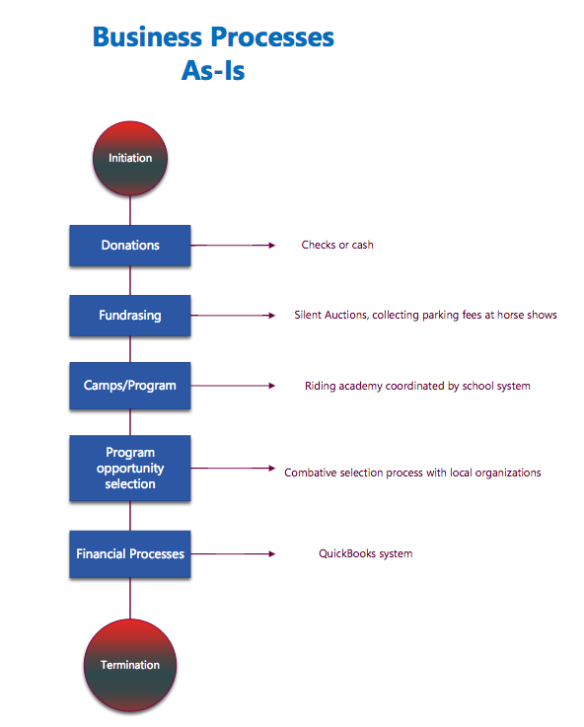

**AS – IS Model**

The As-Is model shows the system in its current state. The As-Is system is the combination of people, processes, data, and technology that currently perform the tasks and functions of the system HOOF uses. The process begins with initiation and goes through donations, fundraising, camps/program, program opportunity selection and financial processes then ends with termination.

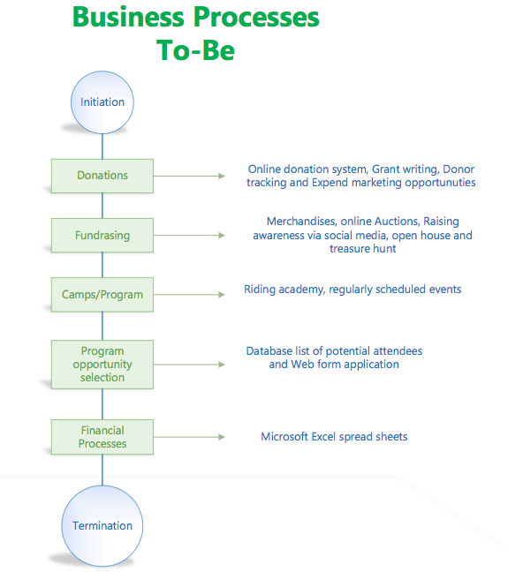

**TO-BE Model**

The To-Be model shows the proposed system which was developed on the basis of the analysis done on the existing HOOF system. The To-Be system is the combination of people, processes, data, and technology that will perform the required tasks and functions using the HOOF system. The process begins with initiation and goes through donations, fundraising, camps/program, program opportunity selection and financial processes and ends with termination.

**System Requirements**

The following is a list of requirements the GallOp System will need to include in order to best serve HOOF, Inc. . Included are all potential requirements that we identified while collecting information from HOOF.

**Functional requirements**

1. Manage Volunteers data:
   1. The system will collect volunteers information.
   2. The system will store volunteers information.
   3. The system will be able to delete/modify volunteer information.
2. Manage participants data:
   1. The system will track participants information.
   2. The system will store participants information.
   3. The system will be able to delete/modify participants information.
3. Manage donors data:
   1. The system will collect donor information.
   2. The system will Store donor information.
   3. The system will be able to delete/modify donor information.
4. Produce events:
   1. The system will allow Auction director to manage events.
   2. The system will allow director of public relations to manage public relationships and marketing.
   3. The system will support the social media features
5. Manage website:
   1. The HOOF administrators will be able to add content on the website.
   2. The HOOF administrators will be able to update content on the website.
   3. The HOOF administrators will be able to delete/modify content on the website.

**Non-functional requirement**

1. Operational requirements
   1. The system will operate in windows environment.
   2. The system should be able to connect to peripheral devices.
   3. The system should have the capability to perform routine backup.
   4. The system will centralize data that can be stored on a cloud platform.
   5. The system will use Microsoft office suite application for basic business processes.
2. Performance requirements.
   1. The system will store new applications.
   2. The system will retrieve new applications.
   3. The system will allow data to be easily shared amongst users.
   4. The system should be able to track volunteers hours
   5. The system will allow users to collect financial data via *Excel*
3. Security requirements.
   1. Users will be granted permissions as operate.
   2. All devices should be password protected.
   3. The system should be able to track users activities on the website

**Use Cases**

The following are the envisioned use cases for our proposed HOOF system solution. Each instance has three use cases: an add, a delete and an edit functionality. These use cases describe what the HOOF end user will be able to accomplish through the information system. The case name: the instance’s function, actor: main end user, description: brief description of the functionality and risk: based off of our assessment in the risk analysis, will either ‘low’ or ‘high’.

**1. Case name:** Add Volunteers

**Actor:** HOOF Administrator

**Description:** A hoof administrator will be able to add a new volunteer.

**Risk:** Low

**2. Case name:** Delete Volunteers

**Actor:** HOOF Administrator

**Description:** A hoof administrator will be able to delete a volunteer who leaves.

**Risk:** Low

**3. Case name:** Edit Volunteers

**Actor:** HOOF Administrator

**Description:** A hoof administrator will be able to edit a volunteer’s information.

**Risk:** Low

**4. Case name:** Add Volunteer Hours

**Actor:** Volunteer

**Description:** A hoof volunteer will be able to add hours volunteered through the volunteer portal on the website.

**Risk:** Low

**5. Case name:** Delete Volunteer Hours

**Actor:** Volunteer

**Description:** A hoof volunteer will be able to delete hours volunteered to work through the volunteer portal on the website.

**Risk:** Low

**6. Case name:** Edit Volunteer Hours

**Actor:** Volunteer

**Description:** A hoof volunteer will be able to edit hours scheduled to volunteer through the volunteer portal on the website.

**Risk:** Low

**7. Case name:** Add Volunteer Information

**Actor:** HOOF Administrator

**Description:** A HOOF Administrator will be able to add pertinent volunteer information to the portal.

**Risk:** Low

**8. Case name:** Delete Volunteer Information

**Actor:** HOOF Administrator

**Description:** A HOOF Administrator will be able to delete volunteer information that is no longer pertinent.

**Risk:** Low

**9. Case name:** Edit Volunteer Information

**Actor:** HOOF Administrator

**Description:** A HOOF Administrator will be able to edit volunteer information as needed.

**Risk:** Low

**10. Case name:** Add a Child

**Actor:** HOOF Administrator

**Description:**  A hoof administrator will be able to add a child’s information.

**Risk:** High

**11. Case name:** Delete a Child

**Actor:** HOOF Administrator

**Description:**  A hoof administrator will be able to delete a child’s information.

**Risk:** Low

**12. Case name:** Edit a Child

**Actor:** HOOF Administrator

**Description:**  A hoof administrator will be able to edit a child’s information.

**Risk:** High

**13. Case name:** Add School Information

**Actor:** HOOF Administrator

**Description:** A hoof administrator will be able to add participating schools. (name/contact information)

**Risk:** Low

**14. Case name:** Delete School Information

**Actor:** HOOF Administrator

**Description:** A hoof administrator will be able to delete participating schools. (name/contact information)

**Risk:** Low

**15. Case name:** Edit School Information

**Actor:** HOOF Administrator

**Description:** A hoof administrator will be able to edit information for participating schools. (name/contact information)

**Risk:** Low

**16. Case name:** Add Potential Grants

**Actor:** Designated Grant Writer

**Description:** A hoof administrator or designated grant writer will be able to add a potential grant to the list.

**Risk:** Low

**17. Case name:** Delete Potential Grants

**Actor:** Designated Grant Writer

**Description:** A hoof administrator or designated grant writer will be able to delete a potential grant from the list.

**Risk:** Low

**18. Case name:** Edit Potential Grants

**Actor:** Designated Grant Writer

**Description:** A hoof administrator or designated grant writer will be able to edit information on potential grants.

**Risk:** Low

**19. Case name:** Add a Grant Application

**Actor:** Designated Grant Writer

**Description:** A hoof administrator or designated grant writer will be able to add grants applied for.

**Risk:** High

**20. Case name:** Delete a Grant Application

**Actor:** Designated Grant Writer

**Description:** A hoof administrator or designated grant writer will be able to delete a grant application applied for.

**Risk:** Low

**21. Case name:** Edit a Grant Application

**Actor:** Designated Grant Writer

**Description:** A hoof administrator or designated grant writer will be able to edit information on grant applications.

**Risk:** High

**22. Case name:** Add to Board of Directors

**Actor:** HOOF Administrators

**Description:** A hoof administrator will be able to add a member to the Board of Directors.

**Risk:** Low

**23. Case name:** Delete from Board of Directors

**Actor:** HOOF Administrators

**Description:** A hoof administrator will be able to delete a member of the Board of Directors.

**Risk:** Low

**24. Case name:** Edit to Board of Directors

**Actor:** HOOF Administrators

**Description:** A hoof administrator will be able to edit information on Board of Directors.

**Risk:** Low

**25. Case name:** Add to Mailing List

**Actor:** HOOF Administrator

**Description:** A hoof administrator will be able to add a member to the mailing list.

**Risk:** Low

**26. Case name:** Delete from Mailing List

**Actor:** HOOF Administrator

**Description:** A hoof administrator will be able to delete a contact on the mailing list.

**Risk:** Low

**27. Case name:** Edit Mailing List

**Actor:** HOOF Administrator

**Description:** A hoof administrator will be able to edit information on the mailing list.

**Risk:** Low

**28. Case name:** Add Scheduled Mail

**Actor:** HOOF Administrator

**Description:** A hoof administrator will be able to add a scheduled email to the mailing list.

**Risk:** Low

**29. Case name:** Delete Scheduled Mail

**Actor:** HOOF Administrator

**Description:** A hoof administrator will be able to delete a scheduled email to the mailing list.

**Risk:** Low

**30. Case name:** Edit Scheduled Mail

**Actor:** HOOF Administrator

**Description:** A hoof administrator will be able to edit scheduled emails to the mailing list.

**Risk:** Low

**31. Case name:** Add Content to Website

**Actor:** HOOF Administrator

**Description:** A hoof administrator will be able to add content to the website through WordPress.

**Risk:** High

**32. Case name:** Delete Content from Website

**Actor:** HOOF Administrator

**Description:** A hoof administrator will be able to delete content from the website through WordPress.

**Risk:** High

**33. Case name:** Edit Content to Website

**Actor:** HOOF Administrator

**Description:** A hoof administrator will be able to edit content on the website through WordPress.

**Risk:** High

**34. Case name:**  Add Silent Auction Inventory

**Actor:** Auction Director

**Description:** The auction director will be able to add current inventory items.

**Risk:** Low

**35. Case name:**  Delete Silent Auction Inventory

**Actor:** Auction Director

**Description:** The auction director will be able to delete current inventory items.

**Risk:** Low

**36. Case name:**  Edit Silent Auction Inventory

**Actor:** Auction Director

**Description:** The auction director will be able to edit current inventory items.

**Risk:** Low

**37. Case name:** Add Silent Auction Information

**Actor:** Silent Auction Director

**Description:** The auction director will be able to add information on the silent auctions.

**Risk:** Low

**38. Case name:** Delete Silent Auction Information

**Actor:** Silent Auction Director

**Description:** The auction director will be able to delete information on the silent auctions.

**Risk:** Low

**39. Case name:** Edit Silent Auction Information

**Actor:** Silent Auction Director

**Description:** The auction director will be able to edit the information on the silent auctions.

**Risk:** Low

**40. Case name:** Add Media Contact

**Actor:**  Director of Public Relations

**Description:** The director of public relations will be able to add information on media contacts.

**Risk:** Low

**41. Case name:** Delete Media Contact

**Actor:**  Director of Public Relations

**Description:** The director of public relations will be able to delete information on media contacts.

**Risk:** Low

**42. Case name:** Edit Media Contact

**Actor:**  Director of Public Relations

**Description:** The director of public relations will be able to edit information on media contacts.

**Risk:** Low

**43. Case name:** Add Social Media Content

**Actor:** Social Media Manager

**Description:** The social media manager will be able to add posts and comments to social media.

**Risk:** Low

**44. Case name:** Delete Social Media Content

**Actor:** Social Media Manager

**Description:** The social media manager will be able to delete content from social media.

**Risk:** Low

**45. Case name:** Edit Social Media Content

**Actor:** Social Media Manager

**Description:** The social media manager will be able to edit content on social media.

**Risk:** Low

**46. Case name:** Add Financial Information

**Actor:** Accountant

**Description:** The social media manager will be able to add revenue and expenses.

**Risk:** High

**47. Case name:** Delete Financial Information

**Actor:** Accountant

**Description:** The social media manager will be able to delete revenue and expenses.

**Risk:** High

**48. Case name:** Edit Financial Information

**Actor:** Accountant

**Description:** The social media manager will be able to edit revenue and expenses.

**Risk:** High

**49. Case name:** Add an Administrator

**Actor:** HOOF Administrator

**Description:** The HOOF administrator will be able to add administrative permissions to other members.

**Risk:** High

**50. Case name:** Delete an Administrator

**Actor:** HOOF Administrator

**Description:** The HOOF administrator will be able to delete administrative permissions for other members.

**Risk:** High

**51. Case name:** Edit an Administrator

**Actor:** HOOF Administrator

**Description:** The HOOF administrator will be able to edit administrative permissions for other members.

**Risk:** High

**52. Case name:** Add a Donor

**Actor:** HOOF Administrator

**Description:** The HOOF administrator will be able to add donor information.

**Risk:** High

**53. Case name:** Delete a Donor

**Actor:** HOOF Administrator

**Description:** The HOOF administrator will be able to delete donor information.

**Risk:** Low

**54. Case name:** Edit a Donor

**Actor:** HOOF Administrator

**Description:** The HOOF administrator will be able to edit donor information.

**Risk:** High

**55. Case name:** Add a Recurring Donation

**Actor:** Donors

**Description:** The donors will be able to add donations or recurring donations.

**Risk:** High

**56. Case name:** Delete a Recurring Donation

**Actor:** Donors

**Description:** The donors will be able to delete recurring donations.

**Risk:** High

**57. Case name:** Edit a Recurring Donation

**Actor:** Donors

**Description:** The donors will be able to edit recurring donations.

**Risk:** High

**58. Case name:** Add an Event

**Actor:** HOOF Administrator

**Description:** The HOOF Administrator will be able to add information for events.

**Risk:** Low

**59. Case name:** Edit an Event

**Actor:** HOOF Administrator

**Description:** The HOOF Administrator will be able to edit information for events.

**Risk:** Low

**60. Case name:** Delete an Event

**Actor:** HOOF Administrator

**Description:** The HOOF Administrator will be able to delete information for events.

**Risk:** Low

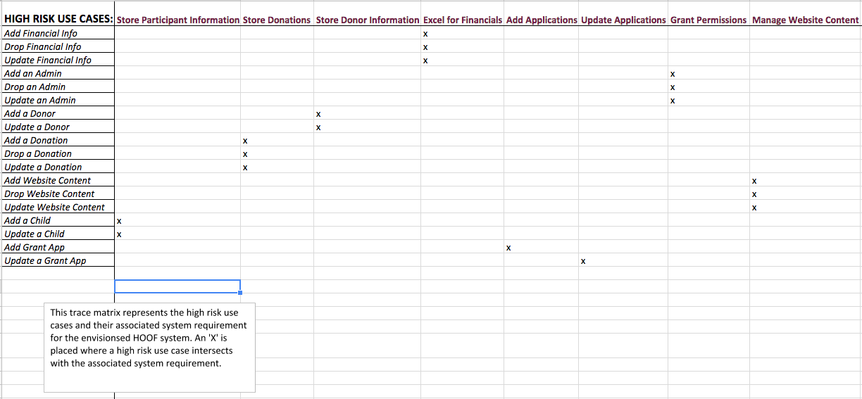

**The System Architecture**

We attached 2 system diagrams from the design viewpoint and realization viewpoint. Purpose of this is to give a good visual for how the system will system will operate and what the main objectives are. The design VP is a simple diagram and the realization VP will build off that and will show what the system is aiming to be.

**Design Viewpoint**

HOOF’s main process is having a centralized form of a database where they can communicate to their client. The design VP shows the general outline between administrators and end users and how they will interact and shows what is in between. The design is simple as the organization will only need to implement the cloud service, payment system for the donation link, and the content management systems with WordPress along with the domain fee. The end users are HOOF organizational members and visitors that heard about HOOF. They would access the site through their mobile cell phone or a personal desktop/laptop. The content management system will house the website and display to the visitors what they need to see and things they can do. Information will go between the cloud and the content system, along with the payment system that will function with the donate link on the website.

**Realization Viewpoint**

The realization VP is a better diagram that shows what services are in between. Our system simply shows that the members can access HOOF’s website over the internet and how it will then direct them to their landing page hosted on WordPress. On the website, the donate button is integrated with iATS payment systems that’s specialized for nonprofits. All of the traffic will cycle in-between the database hosted on Microsoft’s Azure cloud service. The board members will also have access to the cloud service once they pass through the system firewall. On the left side of the diagram, the administrators will access organizational files and information through the cloud when they bypass the system firewall. The firewall is denoted as a red brick wall in-between the system nodes. The firewall is a part of the system that is designed to block unauthorized access while allowing information to transfer outwards. This is critical for this organization’s administrators and board members to have access to the cloud service whilst preventing access from the outside. This consolidates information in one safer place which is better than just storing the information on multiple devices where anyone can have access if they get to it.

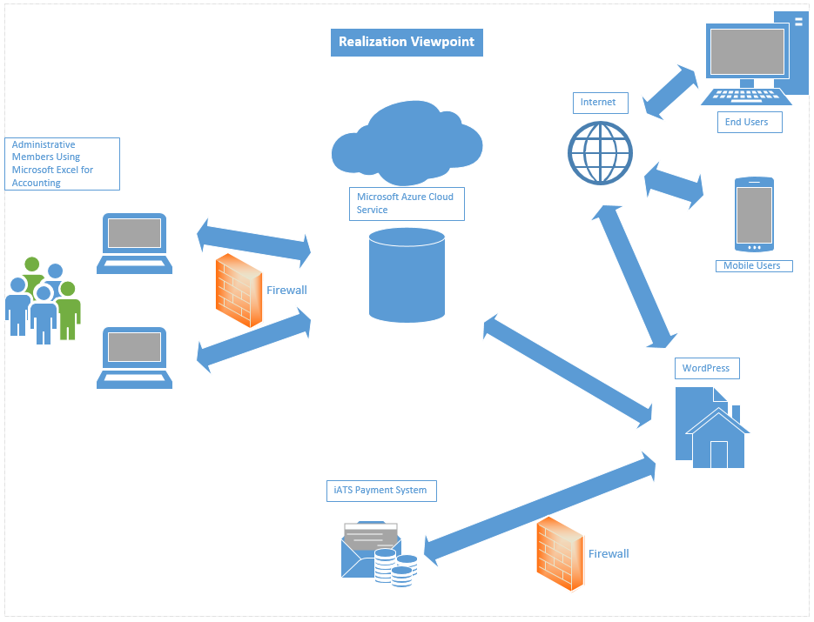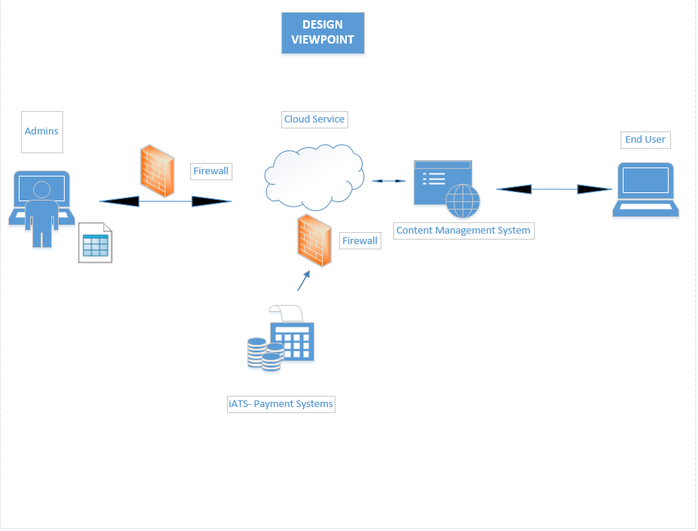

**Risk Analysis**

A use case is high risk when the use case’s loss of functioning results in the organization’s loss of funding. Low risk use cases do not result in the direct loss of funding for the organization. The more the risk is attended to, the less likely the loss of functioning is to occur.

Other areas of risk are related to hardware, software and security. These areas of risk are assessed by whether they result in a loss of funding or result in a breach of confidential data. Low risk areas do not result in a loss of funding or breach of data. The following is breakdown of the other areas of risk and their risk level:

* Hardware Functioning: High Risk

The devices used to store and access the database, edit content on the website, market on social media and communicate with other members and donors are essential to these processes. If there were a loss in hardware functioning, these key areas of the organization would not be able to function properly.

* Software Functioning: High Risk

The software used to store data, retrieve and analyze data, edit the content of the website and communicate is essential to the organization’s functioning. A good understanding on their interfaces and techniques are also important as well. Reliable software and adequate training are requirements to keep software functioning as it should.

* Website Functioning: High Risk

The website provides means for accepting donations, spreading awareness of HOOF’s mission, recruiting volunteers, recruiting at risk youth and creating a buzz about events. If the functioning of the website goes down, then all of these processes will be down, resulting in a loss of funding, awareness and activity in the organization.

* Database Security : High Risk

The database will contain sensitive and confidential data such as financial information on the organization and personal information about HOOF members and the at risk youth that attend their summer camps. Confidential data being leaked could lead to distrust in the community, which could lead to a decline in the organization’s activity.

Risk is constantly being addressed during the iterations of the Elaboration phase. As the system continues to be refined, more clarification will allow for more accurate assessments and evaluation. It is important to assess the high risk cases in order to better prepare for them.

**Team Charter**

Team Goal:

Fine Equine is a team of six University of Louisville College of Business students. Our team’s task is assisting a Kentucky-grown non-profit organization, Horses Offering Opportunities for the Future, Inc. (HOOF, Inc.) with the creation and integration of an information system into its current environment. Fine Equine will examine the “as-is” model of HOOF, Inc., to discover the operational problems it is currently facing. We will then determine the type of information system needed to add value to the organization. The overarching mission is to proactively save time and money for the organization, as well as increase the amount of money made available through donors, fundraising events, and other forms of sponsorship.

Team Meetings:

The team will meet throughout the University of Louisville’s Spring 2018 semester. The CIS-320 class is scheduled to meet on Mondays and Wednesdays at 9:30AM-10:45AM in the U of L College of Business (Room 003). This will provide a regular opportunity to meet and discuss project matters. In addition, the team has agreed to **meet every Wednesday at 4:00PM** in a reserved room in the College of Business. In addition, meetings can be scheduled as needed via the team GroupMe chat.

Meeting responsibilities are as follows:

* **Aziz Arrak** - will be in charge with the locating and booking of the room and will communicate this location to the team when it is determined.
* **Diana Durig** - will set the agenda of the meeting
* **Madeline Cowgill** - will take the minutes of the meeting as the official notetaker.

Team Communication:

The team has exchanged personal contact information and may communicate via email, phone or text. The main channel for texting is via GroupMe for informal communication. Work will be primarily conducted through a fully shared Google Docs folder created by Vin Lam for this purpose. Communication with the instructor, Dr. Robert Barker will be via email or in person during class or office hours. His contact information may be found on the class syllabus. Communication with the client, HOOF, Inc. will be primarily via email. In respect of the client’s time, the teams have agreed to post project questions as a group in order to avoid duplication. Questions and Answers will be posted in the Blackboard discussion forum at: [**https://tinyurl.com/y8w78l7k**](https://tinyurl.com/y8w78l7k)**.**

Team Decisions:

Important team decisions will be made by a majority vote. Best efforts will be made by all team members to ensure that work is evenly and fairly distributed. Smaller decisions have been broken down and roles have been designated accordingly. (See Team Meetings above) When designating tasks, the group will break down the tasks and they will be assigned on a first call basis.

Team Project Repository:  
 The team has designated a Google Drive folder as its project repository for the duration of the project. The drive is organized into separate designated folders for better accessibility and efficiency. The project folders are accessible to all members; view and edit permissions have been granted to all members. **It is the responsibility of all individual group members to back up their work on a regular basis to mitigate against loss of work or data.**

**Gantt Chart**

The following Gantt Chart shows a broad overview of the project tasks involved with the Fine Equine GallOp project for HOOF, Inc. Each task is represented by a horizontal charted line representing the amount of time allocated to that task.

Each line in the Gantt chart is followed by the initials of the project team members to show the member assigned to the project:

**Aziz Arrak - AA**

**Madee Cowgill - MC**

**Diana Durig - DD**

**Vin Lam - VL**

**Shivani Patel - SP**

**Henry Wang - HW**

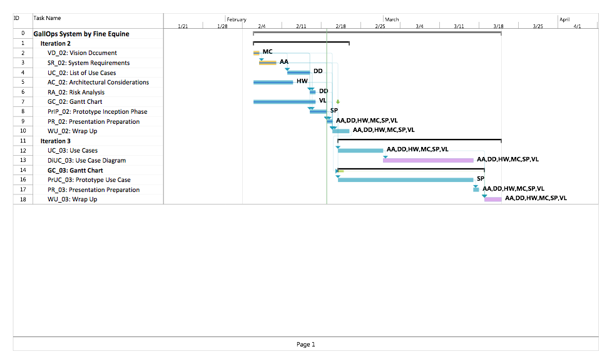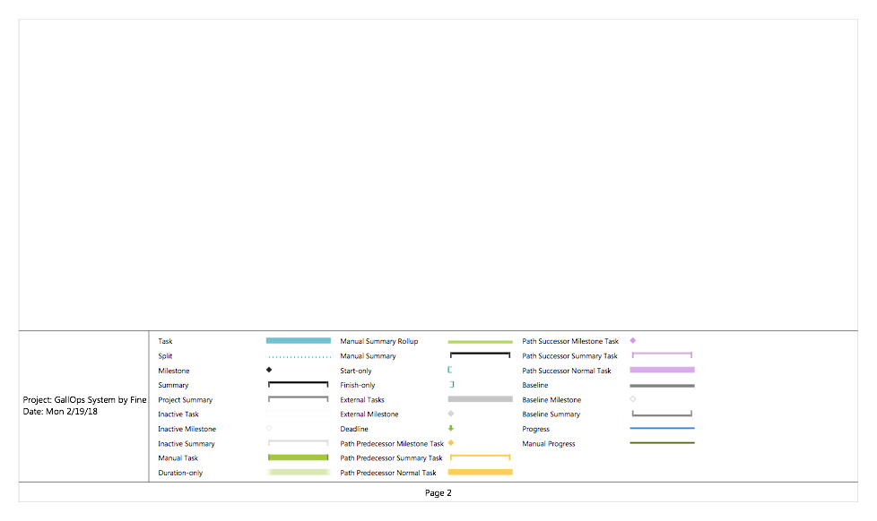

**Inception Phase Prototype**

We have included several prototypes that illustrate how we intend to meet the requirements that we have listed in the system requirements of this specification. We will list the prototypes here:

***Landing Page* -** This is the homepage that viewers will see when they first visit hoofky.org. This page includes tabs for home, about us, media, upcoming events, volunteer portal, services, and donate. It also includes the social media bar in the footer of the page, a link to sign up for the HOOF mailing list, and the Admin Login for HOOF administrators.

***Calendar Page* -** This prototype displays the upcoming events in the given month in a calendar format for an easy view for the viewers. This prototype is displayed under the “Upcoming Events” tab in the website. Events will be found under the corresponding day in the calendar that is hyperlinked to a more detailed webpage of the event. Also, the location of the event will be displayed alongside the calendar.

***Donation Page -*** This prototype displays the donation form. This method allows potential donors to donate by providing their name, email, country, address, city, state, zip and payment information. It will ask for the amount once you will click the donate button. This prototype will be found under the “Donate” tab in the website.

***Volunteer Portal -*** This prototype displays a volunteer form for the new volunteers to sign up for HOOF. Current volunteers can log in under the “Already a volunteer? Click here” link where they can store their days and hours they worked. Potential volunteers can easily and securely input their information into the form and submit it to HOOF which will then be stored in the database. This will allow volunteers to manage their information with ease.

